



**Optimization**

**For**

**Analytics**



**Submitted by:**

Adeel Nasir (gd8408)

Venu Madhava Reddy Kotla (eg1265)

Ahamed Shaik(uw4621)

Chandana Kandula(dl5702)

Supraja Bakki(gs5133)



DermaGlow

PROJECT SUMMARY

This project optimized the profit of Derma Glow's facial product line using a non-linear programming (NLP) model. For optimal solution we used NLP model instead of LP because of real world problem. We decided to use NLP instead of linear programming (LP) because NLP allowed for non-linearities to create a more realistic model.

While calculation in Excel, Multistart feature used to select the best optimal solution for Derma Glow's facial product line. When optimizing a complex problem like this one, it can be challenging to determine where and how to start. By using the multistart option, we were able to initiate the optimization process from multiple starting points and then select the best solution. Additionally, starting the optimization process with the GRG nonlinear algorithm was a good choice, as it is well-suited for solving non-linear optimization problems. By using this algorithm, you were able to find the global optimal solution (Maxima) for Derma Glow's facial product line.

In this case five facial product used with different unit price, profit and demand. Demand calculation was tricky part, because of that, we use more thoughtful and sophisticated approach to optimize the profit of Derma Glow's facial product line. By using the Constant Elasticity Demand function, we were able to calculate the demand for each product and arrive at a global optimal solution that maximized the company's profit.

In conclusion, in was beneficial to use NLP model with multistart and elasticity of demand function to find the best optimal solution for Derma Glow's facial product line. By taking into account the non-constant return of scales, including demand, price, and profit per unit, we created more realistic and accurate model of the company's product line.

COMPANY INTRODUCTION

Darma glow Cosmetics participates in the growing gluten-free cosmetics industry. The cosmetics industry struggled during the recession, but has rebounded, with healthy 5% growth in 2022 the industry shows especially strong growth in the organic sectors in India. Darma glow all products line are gluten free products. Darma glow deals in multiple cosmetic product line including skin care, hair treatment and colors. Company’s financial condition is relatively better in economic recession as compare to other industries in India.

Cosmetics industry is mature and stable, the gluten-free products industry is relatively new and volatile. Since 2009, public awareness of gluten-intolerance has grown significantly.

**Today, 10% of the US population eats gluten-free. (That’s more than the entire population of Texas)**

**Company Products**

**Skin Care**

* Ayurvedic Facial
* Botanical Facial
* Herbal Facial Skin Lifting treatment
* 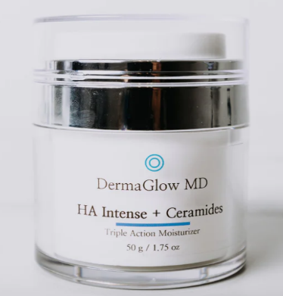Hydra Facial

**Personal & Hair**

* Hair treatment
* Hair Extension
* Hair color

**Current** **Problem**

Darma glow is facing some problems in increasing product because of multiple factors including range of products lines, unit prices, marketing analysis and demand control factors. Although sales of the five facials manufactured by his company have been brisk, the company is not earning the level of profits that management wants to achieve. Having established a reputation for high quality and reliability, management believes that they can increase profits by increasing the prices of the products. Unfortunately, increase in price was not a rational decision. Because of recession in market company increased the prices by 40 to 70%. The cost of product is somehow under the control of the management but price and demand is fluctuating without any possible and controlled reason. So, company management decided to optimized the profit with satisfactory demand.

**Proposed Solution**

With the current situation of company and recession in the market it is not feasible to increase the price of products because we know that if price increase the demand will decrease according to elasticity of demand function. The proposed solution is to calculate the approx. demand with the demand function (mentioned in next sheet) and price with the help of Excel solver.

Optimization strategy in this project involves using NLP to develop a model. The goal is to create a model that can handle complex conditions with multiple variables in order to calculate the optimal solution for pricing. To achieve this, the NLP model will likely need to be trained on a large dataset. Once the model is trained, it can be used to analyze new data and make pricing decisions based on the optimal solution calculated by the model. The model will likely be run multiple times with different starting points in order to find the best solution. This approach can be useful for finding the true global optimal solution, rather than settling for a local optimal solution that may not be the best overall.

Overall, the optimization strategy in this project seems to be focused on using NLP to create a powerful pricing model that can handle complex conditions and find the best possible solution for each product.

**Main Chapter**

**Data Collection**

Management is trying to solve a pricing problem for their products. To gain insights into the market demand for their products, they have engaged a financial department to estimate the level of demand for five products at various prices. By analyzing this data, the management can make informed decisions about pricing their products based on the level of demand in the market. To further analyze the relationships between price and market demand, the finance department has collected information on the monthly product prices and respective demands for each product over the last 10 months. This data can be used to analyze the trends in demand and price and identify any patterns or relationships between them.

It is important to note that the data collected may not be comprehensive, and there may be other factors that influence market demand besides price, such as the quality of the products or the level of competition in the market. Therefore, it is important to use a rigorous analytical approach that takes into account all relevant factors in order to make informed pricing decisions.

**Historical Data for Prices and Demand for following products**

Skin Lifting Facial

Botanical Facial

Ayurvedic Facial

|  |  |  |  |  |  |  |  |
| --- | --- | --- | --- | --- | --- | --- | --- |
| Price | Demand |  | Price | Demand |  | Price | Demand |
| 500 | 1350 |  | 500 | 1350 |  | 600 | 1520 |
| 700 | 980 |  | 700 | 980 |  | 808 | 1390 |
| 900 | 820 |  | 900 | 820 |  | 1050 | 1100 |
| 1100 | 750 |  | 1100 | 750 |  | 1230 | 900 |
| 1300 | 670 |  | 1300 | 670 |  | 1440 | 790 |
| 1500 | 640 |  | 1500 | 640 |  | 1670 | 700 |
| 1700 | 440 |  | 1700 | 440 |  | 1800 | 400 |
| 1900 | 320 |  | 1900 | 320 |  | 2010 | 390 |
| 2100 | 200 |  | 2100 | 200 |  | 2220 | 200 |
| 2300 | 190 |  | 2300 | 190 |  | 2410 | 150 |

Hydra Facial

Hair treatment

|  |  |  |  |  |
| --- | --- | --- | --- | --- |
| Price | Demand |  | Price | Demand |
| 120 | 820 |  | 1500 | 510 |
| 140 | 780 |  | 1770 | 490 |
| 160 | 500 |  | 1980 | 490 |
| 180 | 510 |  | 2100 | 300 |
| 200 | 460 |  | 2320 | 250 |
| 220 | 320 |  | 2510 | 250 |
| 240 | 290 |  | 2770 | 210 |
| 260 | 220 |  | 2999 | 170 |
| 280 | 150 |  | 3199 | 100 |
| 300 | 120 |  | 3339 | 75 |

**Data Analysis**

This scatter chart is basically explaining the relationship between price and demand. This is more than non-linear relationship. These trend lines in different colors covers the points in better way then linear function.

The demand Y in both charts is not the linear function of price X. We are using **Power function** and this function is defined by two parameters. First Parameter in front of X **(3,462,658.99 and 69,774.35 etc)** and power **(-1.23 and -0.95 etc)** explains that value of demand when price is equal to 1.

**Analysis:**

**>** If prices increase by 1% Demand will decrease by -1.23.

> Coefficient of determination (R2) represents the strength of this function. Which means demand fluctuation with price.

> 90% of variation in demand can be explained by price X.

D = apb

**Analysis:**

**>** If prices increase by 1% Demand will decrease by -0.95

> R2= 85% Means 85% of variation in demand can be explained by price X.

>This is pretty good relationship.

**Analysis:**

**>** If prices increase by 1% Demand will decrease by -1.60

> R2= 82% Means 82% of variation in demand can be explained by price X.

>This is pretty good relationship.

**Analysis:**

**>** If prices increase by 1% Demand will decrease by -2.06

> R2= 92% Means 92% of variation in demand can be explained by price X.

>This is pretty good relationship.

**Analysis:**

**>** If prices increase by 1% Demand will decrease by -2.33

> R2= 82% Means 82% of variation in demand can be explained by price X.

>This is pretty good relationship.

**Optimization Modeling**

After getting all the information about this case we can make our model with decision variables and constraints.

**Decision Variables:**

Paf = Price for Ayurvedic Facial, $

Pbf= Price for Botanical Facial, $

Pslt= Price for Skin Lifting Treatment, $

Phc= Price for Hair Color, $

Pht= Price for Hair Treatment, $

**Inputs:**

**Demand and Cost of for Ayurvedic Facial**

Daf = Demand for Ayurvedic Facial based on price, units =3,462,658.99x-1.23

Caf = Cost per Ayurvedic Facial ,$764

**Demand and Cost of for Botanical Facial**

Dbf= Demand for Botanical Facial based on price, units =69,774.35x-0.95

Cbf= Cost per Botanical Facial ,$176

**Demand and Cost of for Skin Lifting**

Dslt= Demand for Skin Lifting Treatment based on price, units =62,640,574.88x-1.60

Cslt= Cost per Skin Lifting Treatment ,$900

**Demand and Cost of for Hydra facial**

Dhc= Demand for Hair Color based on price, units =19,499,366.96x-2.06

Chc= Cost per Hair Color,$195

**Demand and Cost of for Hair Treatment**

Dht= Demand for Hair Treatment based on price, units =16,895,610,555.68x-2.33

Cht= Cost per Hair Treatment ,$1850

|  |
| --- |
| **Objective Function** |
| **Global Maxima (Maximize Profit)** max[(Paf-Caf)Daf + (Pbf-Cbf)Dbf + (Pslt-Cslt)Dslt + (Phc-Chc)Dhc + (Pht-Cht)Dht] |
|  |
| To maximiza the profit by indentifying the Appropirate Price.  The price that would maximize the profit associated with selling Hot Tubs. |  |
|  |

**Constraints:**

|  |  |  |  |
| --- | --- | --- | --- |
|  | LHS |  | RHS |
| Number of Skin Care Products | Daf+Dbf+Dslt | <= | 600 |
| Number of Hair Products | Dhc+Dht | <= | 250 |
| Price of Ayurvedic Facial | Paf | >= | 764 |
| Price of Botanical Facial | Pbf | >= | 176 |
| Price of Skin Lifting Treatment | Pslt | >= | 900 |
| Price of Hair Color | Phc | >= | 195 |
| Price of Hair Treatment | Pht | >= | 1850 |
| Price of Botanical Facial | Pbf | <= | 500 |

Non-Negativity:

|  |
| --- |
| Paf >= 0 |
| Pbf >= 0 |
| Pslt >= 0 |
| Phc >= 0 |
| Pht >= 0 |

**Explanation of NLP Model:**

This is a Non-linear optimization model. Based on the information provided, it sounds like this is a nonlinear optimization model with certain constraints and a nonlinear objective function.

The objective function appears to be a function of price and demand, which means that it is not a linear function of the variables. Nonlinear optimization techniques can be used to find the optimal values of the variables that maximize or minimize the objective function.

The constraints described relate to the allowable range of prices. It is common in optimization problems to have constraints that limit the range of values that the variables can take on. In this case, the constraints specify that prices must be greater than a certain value and cannot be negative.

|  |  |
| --- | --- |
| **Ayurvedic Facial Unit Price** | |
| Unit Cost | $764 |
| Demand Function for Ayurvedic Facial | |
| Constant | 3,462,658.99 |
| Elasticity | -1.23 |

|  |  |
| --- | --- |
| **Botanical Facial Unit Price** | |
| Unit Cost | $176 |
| Demand Function for Botanical Facial | |
| Constant | 69,774.35 |
| Elasticity | -0.95 |

|  |  |
| --- | --- |
| **Skin Lifting Treatment Unit Price** | |
| Unit Cost | $900 |
| Demand Funtion for Skin Lifting Treatment | |
| Constant | 62,640,574.88 |
| Elasticity | -1.6 |

|  |  |
| --- | --- |
| **Hydra Facial Unit Price** | |
| Unit Cost | $195 |
| Demnad Funtion for Hair Color | |
| Constant | 19,499,366.96 |
| Elasticity | -2.06 |

|  |  |
| --- | --- |
| **Hair Treatment Unit Price** | |
| Unit Cost | $1,850 |
| Demand Funtion for Hair Treatment | |
| Constant | 16,895,610,555.68 |
| Elasticity | -2.33 |

|  |  |
| --- | --- |
| **Unit Price of each product** |  |
| Unit price for Ayurvedic Facial | 4000 |
| Unit price for Botanical Facial | 1000 |
| Unit price for Skin Lifting Treatment | 2400 |
| Unit price for Hair Color | 379 |
| Unit price for Hair Treatment | 3241 |
| **Demand for each product** |  |
| Demand for Ayurvedic Facial | 128 |
| Demand for Botanical Facial | 99 |
| Demand for Skin Lifting Treatment | 245 |
| Demand for Hair Color | 95 |
| Demand for Hair Treatment | 112 |
| **Profit for each product** |  |
| Profit from Ayurvedic Facial | $415,800 |
| Profit from Botanical Facial | $81,213 |
| Profit from Skin Lifting Treatment | $366,952 |
| Profit from Hair Color | $17,492 |
| Profit from Hair Treatment | $155,317 |
|  |  |
| **Global Maximum Profit** | **$1,036,773** |

**Brief Explation of Global optimal solution:**

In this spreadsheet we used multistar option to solve the function. Nonlinear optimization and multistart options in Solver are two techniques used to find optimal solutions to complex problems that involve multiple variables and constraints.

Multistart is a technique used to improve the likelihood of finding the global optimum in nonlinear optimization problems.

**Global optimal solution:**

So the optimal profit is $1036773 combined with the price of 4000, 1000, 2400, 379 and 3241 which we calculated by solver. The price is our decision variables.

**Unit Demand:**

The unit demand is 128,99,245, 95 and 112 which is the best combination to get maximum profit.

|  |  |  |  |
| --- | --- | --- | --- |
| **Constraints** | **LHS** |  | **RHS** |
| Price of Ayurvedic Facial | 4000 |  | 764 |
| Price of Botanical Facial | 1000 | >= | 176 |
| Price of Skin Lifting Treatment | 2399.989746 | >= | 900 |
| Price of Hair Color | 378.9519043 | >= | 195 |
| Price of Hair Treatment | 3240.955811 | >= | 1850 |
| Number of Skin Care Products | 471.6870402 | >= | 600 |
| Number of Hair Products | 206.7525691 | <= | 250 |
| Price of Ayurvedic Facial | 4000 | <= | 4000 |
| Price of Botanical Facial | 1000 | <= | 1000 |
| Price of Skin Lifting Treatment | 2400 | <= | 2500 |
| Price of Hair Color | 379 | <= | 400 |
| Price of Hair Treatment | 3241 | <= | 3500 |

**Table 3:**

**Solver Model Explanation:**

**>** Set objective = Maximum Profit Cell

> Changing Variable: Price Cells

> Constraints = Mentioned in Table 3.

> Solving Method : GRG Nonlinear

**Oneway analysis for Solver model in Sheet9 worksheet**

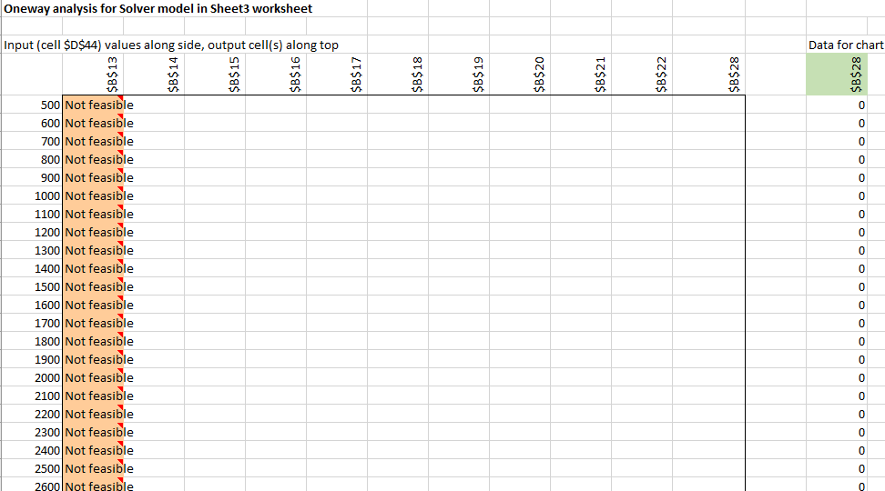

**Results:**

The Oneway analysis using solver was utilized to assess the impact of changes in the price of hair treatment product on the demand and total profit of other products. Specifically, the prices of other products and total profit were recorded as output cells for a range of hair treatment prices, ranging from 500 to 5000 in increments of 100.

The analysis revealed that there were no feasible values for hair treatment prices between 500 and 2700. This suggests that within this range, the prices of other products and total profit are not viable for the business.

On the other hand, hair treatment prices beyond 2800 had a negligible effect on the prices of Ayurvedic facial, Botanical Facial, and Skin lifting treatment. Hence, any changes in hair treatment prices beyond 2800 are unlikely to impact the prices of these products.

The price of hair color was observed to be 383 at a hair treatment price of 2800, and it remained constant thereafter. This indicates that hair color prices are not affected by variations in hair treatment prices beyond 2800.

Furthermore, it was observed that demand for products was insensitive to the changes in hair treatment prices, as demand is a function of price. This means that changes in hair treatment prices are unlikely to significantly impact the demand for other products.

Finally, total profit was found to vary slightly for hair treatment prices between 2800 and 3200, after which it became insensitive to further changes in hair treatment prices. This suggests that within this range, the business can adjust the price of hair treatment to optimize total profit without impacting the prices of other products.

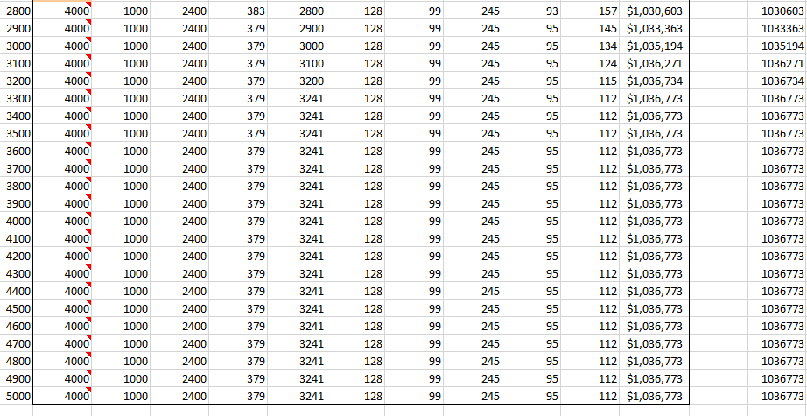

**Conclusion**

The goal of our analysis was to optimize the total profit of a company by varying the prices of its products. To achieve this, we used a price and demand function to determine the demand for each product at different prices, and then used the Solver tool to find the price points that maximize the total profit.

We were able to identify the optimal pricing options for all the products in the company, which can help to maximize its profit. The obtained prices for the products are as follows:

|  |  |
| --- | --- |
| **Unit Price** | |
| Unit price for Ayurvedic Facial | 4000 |
| Unit price for Botanical Facial | 1000 |
| Unit price for Skin Lifting Treatment | 2400 |
| Unit price for Hair Color | 379 |
| Unit price for Hair Treatment | 3241 |

This can be an effective strategy for achieving growth and expansion, as it allows the company to generate more revenue from its existing products without incurring additional costs.

To conduct the analysis, we used the Solver One Way Sensitivity Analysis tool, which helped us to identify the effect of changes in the prices of one product on the prices and demand of all the other products and on the total profit of the company. This analysis enabled us to identify the most effective pricing strategy for each product, and to understand how changes in the price of one product can impact the demand and profitability of other products.

The insights from this analysis report can help the company to build a pricing plan that maximizes its profit, while also taking into account the impact on its customers and competitors. By implementing this pricing plan, the company can achieve its growth and expansion goals, and stay competitive in the market. Overall, the findings from this analysis can provide valuable guidance for any company looking to optimize its pricing strategy and increase its profits.

**Limitations**

In case of any economic recession, this model is not going to work for maximizing the total profit for the company, as there would be very high inflation of prices in case of any economic recession. Thus, the model developed can be put into use only when the economy is stable.

**References**

Practical Management Science – Sixth edition

Authors- Wayne L. Winston, S. Christian Albright